# **Recommendation ${REC}: Install Air Curtain Systems on Doorways**

Recommended Action

Install air curtains to reduce heat transfer through doorways in the production area.

Summary of Estimated Savings and Implementation Costs

|  |  |
| --- | --- |
| Annual Cost Savings | ${ACS} |
| Implementation Cost | ${MIC} |
| Payback Period | ${MPB} |
| Annual Electric Savings | ${ECS} kWh |
| Annual Demand Savings | ${DCS} kW |
| ARC Number | 2.2523.3 |

Current Practice and Observation

In this plant, there are ${AMTSTR} docking doors that are opened for loading and unloading operations. These docking doors are in open position for about ${HRSTR} hours a day during the summer, and the room is kept at freezing temperature to keep the ice from melting. In this case, installing air curtains on doorways will reduce the infiltration of outside air and therefore make-up requirements. Air curtains create a barrier of high velocity air between different environments and that is strong enough to stop winds up to 25 mph. However, closing the doors is more efficient.

Anticipated Savings

It was generally noticed that there is a large amount of heat transferred through doors that are open during loading and unloading. By installing air curtains on doors, the heat transfer can be significantly reduced. The heat transfer through an open door, HT, can be estimated from the Figure below. However, the heat transfer should be modified for the number of operating days, OD, and the average outside temperature to correct for the experimental conditions in the chart below. The summer heat transfer, SHT, is obtained from the following equation:

SHT = HT × (OD / TC) × (TO –TI) / ΔT,

where,

HT = Heat transferred from ${AMT} doors: ${HT} MMBtu/yr

OD = Number of operating days per week: ${DY} days per week

TI = Room temperature: ${RT}oF

TO = Average outside summer temperature: ${OT}oF

C1 = Correction Coefficient: 293 kWh/MMBtu

TC = Time correction based on experimental chart below: 5 days per week

ΔT = Temperature difference correction based on chart below: ${TDC}oF

There are ${AMTSTR} doors in the building and the location and dimension of the doors are given in the table below.

|  |  |  |  |  |
| --- | --- | --- | --- | --- |
| **Location** | **Number of**  **Doors** | **Width**  **(ft)** | **Height**  **(ft)** | **Area, each**  **(ft2)** |
| ${LOC} | ${AMT} | ${DW} | ${DH} | ${AREA} |
| **Total** | **${TOTALDOORS}** |  |  | **${TOTALAREA}** |

**Table 9: Location and Dimension of the Doors in the Building.**

The opening area of the door was calculated as ${AREA} ft2. It is estimated that each door is kept open for about ${HRSTR} hours a day. From the attached graph, the heat transfer factor, HTF, is estimated to be at about ${HTF} MMBtu/yr per door.

The temperature near the door is ${RT}oF. The average summer outside temperature is about ${OT}oF. For the plant conditions of interest, the summer heat transfer, SHT, is:

SHT = ${HT} MMBtu/yr × (${DY}/5) × 293 × (${OT} – ${RT}) / ${TDC}

= ${SHT} kWh/yr.

The air curtain doors are generally ${EF} percent efficient. Thus, the summer energy savings, SES, is calculated to be:

SES = SHT × (ηAC - ηExist)

where,

SHT = Summer heat transfer, ${SHT} kWh/yr

ηAC = Efficiency of air curtain, ${EF}[1],[2]%

ηExist = Efficiency of existing solution (strip curtains) ${EFES}%

SES = ${SHT} kW/yr × (${EF}% - ${EFES}%)

= ${SES} kWh/yr.

The summer demand savings, SDS, for the doors are calculated below:

SDS = ES / OHS × C2 × CF

where,

C2 = Conversion constant: 6 months/yr

CF = Coincidence factor – probability that the equipment contributes to the facility peak demand: 100%/mo

OHS = Summer operating hours for HVAC system: ${OHS} hours (${HRHV}×${DY}×${WK})

SDS = ${SES} kWh/yr / ${OHS} hrs/yr × 6 mos/yr × 100%/mo

= ${SDS} kW/yr

One air curtain system uses approximately ${HPF} HP motor for its operation. The operational costs of air curtain system are calculated as follows:

EU = Electricity usage of the air curtain system

= HP × C3 × OHAC

where,

C3 = Conversion constant: 0.746 kW/HP

HP = Total power of ${AMTSTR} air curtain motors: ${HP} HP

OHAC = Operating hours of air curtains: ${OHAC} hrs/yr (${HPAC} hrs/day, ${DY} days/wk, ${WK} wks/yr)

EU = ${HP} HP × 0.746 kW/HP × ${OHAC} hrs/yr

= ${EU} kWh/yr

DU = Demand usage of the air curtain system

= HP × C3 × C2 × CF

= ${HP} HP × 0.746 kW/HP × 6 mos/yr × 100%/mo

= ${DU} kW/yr

The annual cost savings, ACS of the recommendation is calculated as:

ACS = (SES - EU) × electricity cost + (SDS - DU) × demand cost

= (${SES} kWh/yr - ${EU} kWh/yr) × ${EC}/kWh + (${SDS} kW/yr - ${DU} kW/yr) × ${DC}/kW

= ${ES} kWh/yr × ${EC}/kWh + ${DS} kW/yr × ${DC}/kW

= ${ECS}/yr + ${DCS}/yr

= ${ACS}/yr

Implementation Cost

The cost of an air curtain system is estimated to be ${COST} each. The labor cost for installation of the whole air-curtain system is estimated to be about ${LABOR}. The total implementation cost is ${IC}. It is also recommended that these doors are to be installed with new insulations. <REBATE>

However, there could be energy efficiency rebates available through your utility company, which could potentially reduce the overall capital cost and thereby the payback period. The savings from the rebate is calculated below.

RB = ${ERR}⋅yr/kWh × ES

= ${ERR}⋅yr/kWh × ${ES} kWh/yr

= ${RB}

The incentives are capped at 50% of the project cost, which makes the modified rebate savings, MRB, equal to ${MRB}. Hence, the modified implementation cost, MIC, is estimated as follows:

MIC = IC - MRB

= ${IC} - ${MRB}

= ${MIC}

The modified implementation cost is ${MIC}.</REBATE>

**The annual electric energy savings for this recommendation is ${ES} kWh and annual demand savings is ${DS} kW. The estimated annual cost savings is ${ACS} and, with an implementation cost of about ${MIC}, the payback period would be about ${MPB}.**

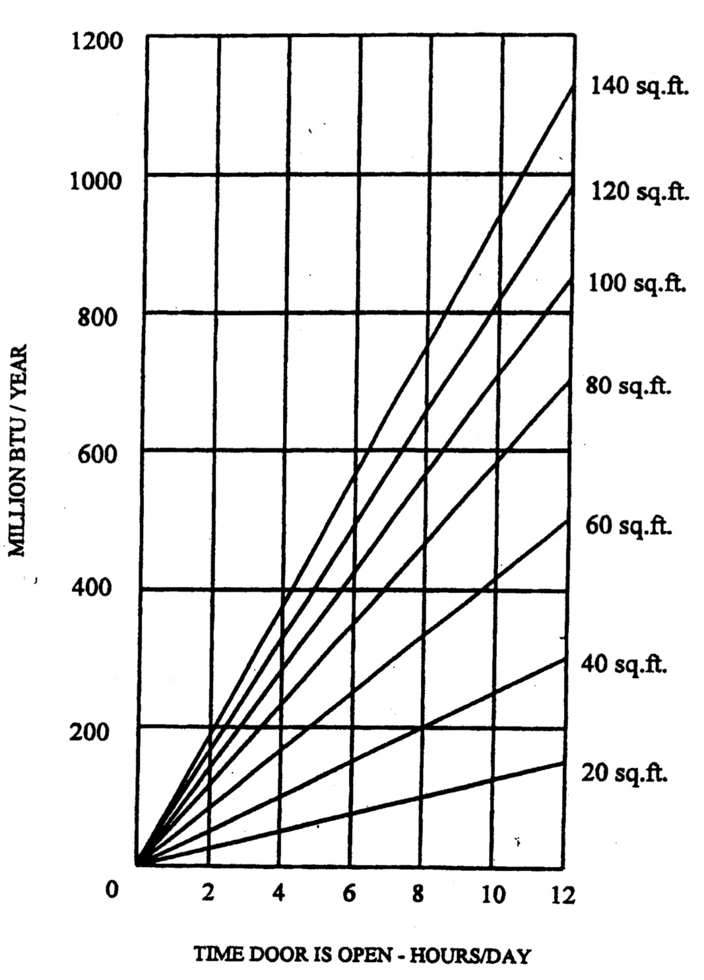

**Figure 1: Annual Heat Transfer from Doors*.**

*Source: Georgia Technical Experimental Station.

1. https://www.bluegiant.com/Files/White-Papers/Benefits-of-Air-Curtains.aspx
2. Hong Ye et al. Study on the influence of air curtain barrier efficiency on infiltration air volume and temperature distribution in large space in winter, Procedia Engineering